# Introduction

### Big Data

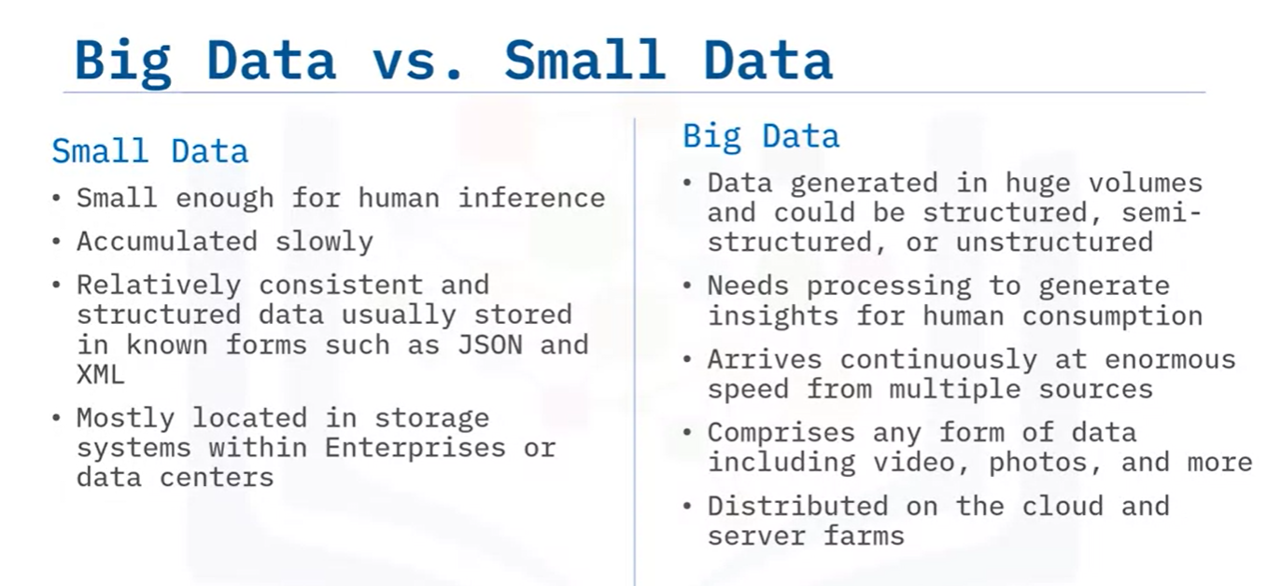

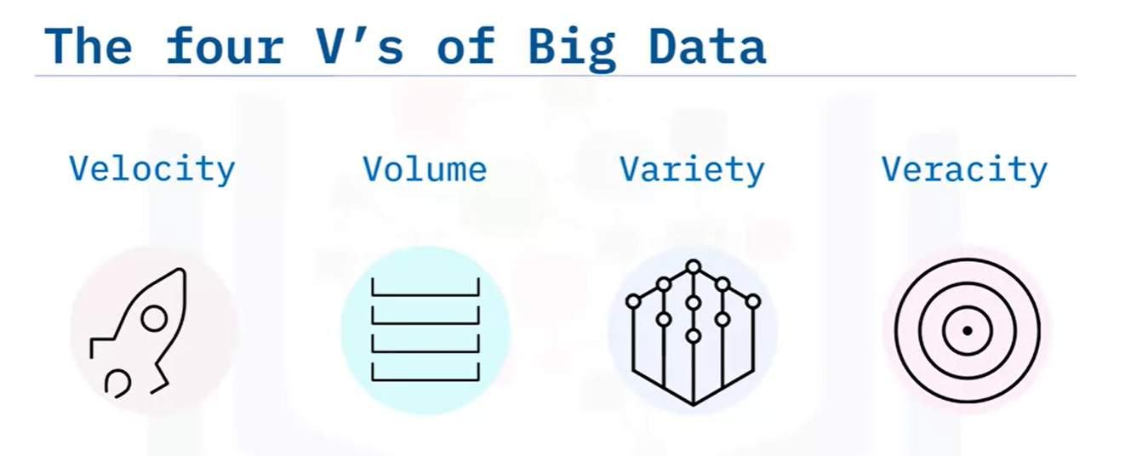

**Velocity:**

Big data is produced at high velocity and has to be processed at similar speed.

**Volume:**

Volume should be able to scale

**Variety:**

Unstructured data is common and comes in various formats

**Veracity:**

To make sure that there is no issue in data, some processes must be established.

## Tools

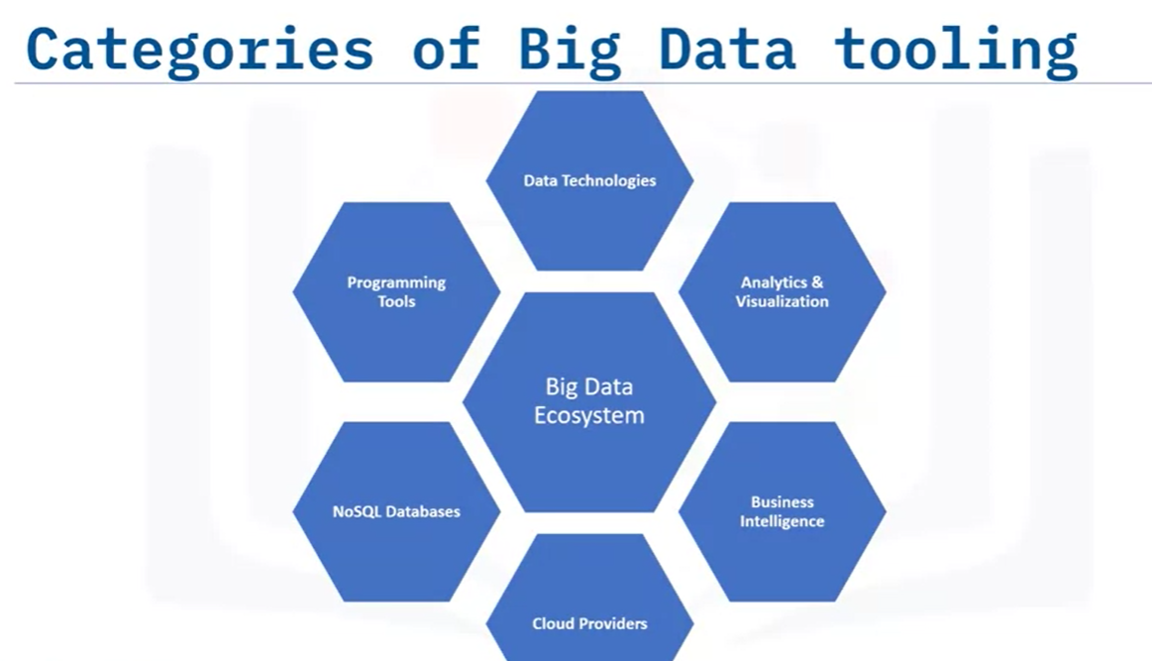

**Programming tools**: R, Python, Scala, Julia

**NoSQL DB**: MongoDB, Cassandra, Redis

**BI Tools**: Cognos, PowerBI

**Visualization**: Tableau

## Opensource and Big Data

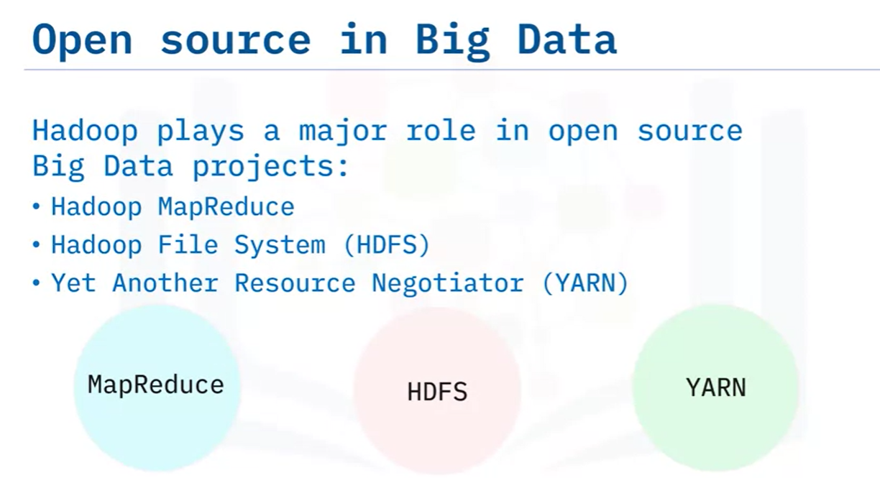

**MapReduce**: To run on Hadoop cluster. Spark has become more popular

**HDFS**: 80% of big data is in this format. S3 is also based on similar principles.

**YARN**: Kubernetes is becoming more popular

**Hive** and **Apache Spark** allow ETL

**Semi-structured data**: e.g. email because there is some structure like from, to but content is not structured

# Hadoop

Opensource framework to process big data (Peta or Exa Bytes). Data maybe structured, unstructured or semi-structured.

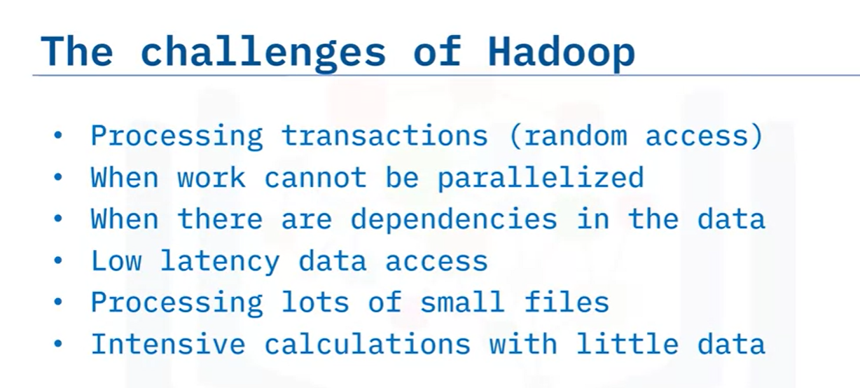

To solve these challenges, Hive was built

## MapReduce

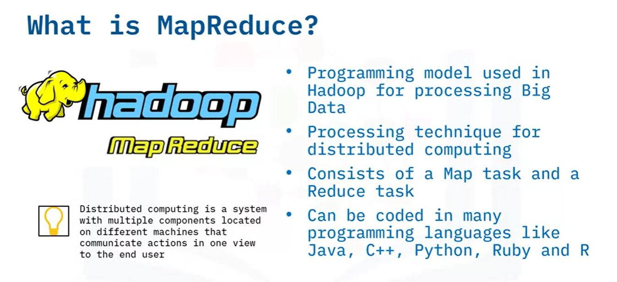

**Map**: Processes data into key-value pairs

**Reducer**: Aggregates and computes result

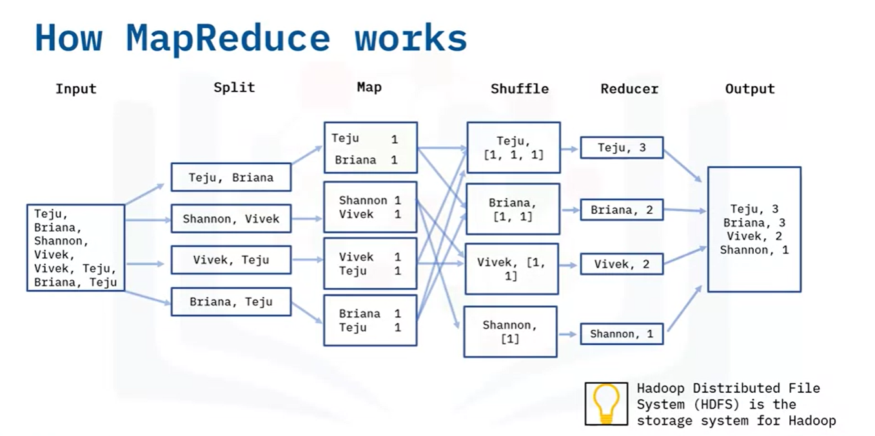

## Hadoop Ecosystem

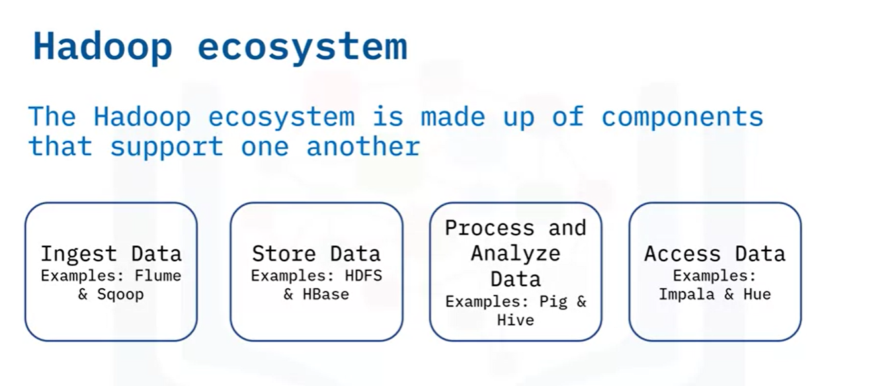

## HDFS

File is broken into blocks

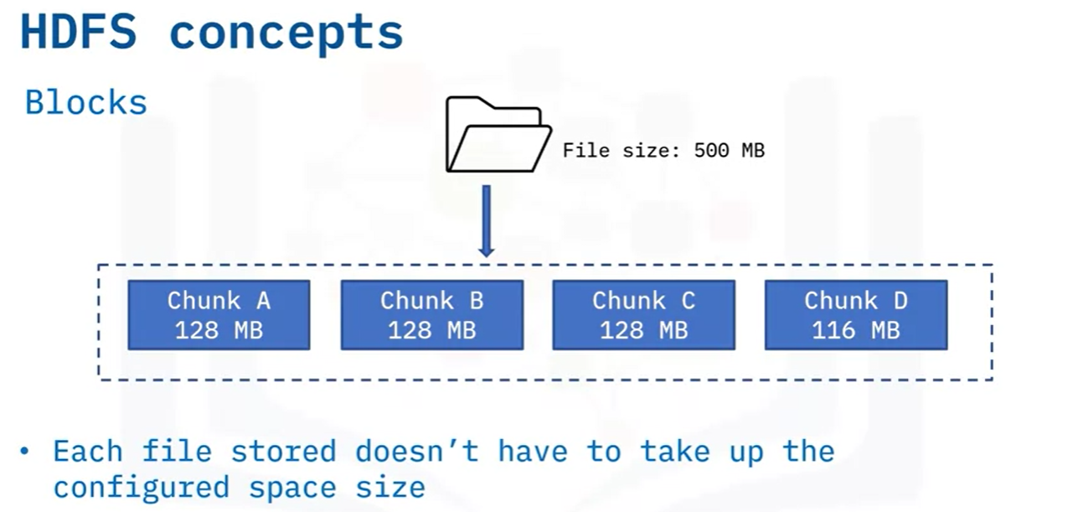

Primary node = name node

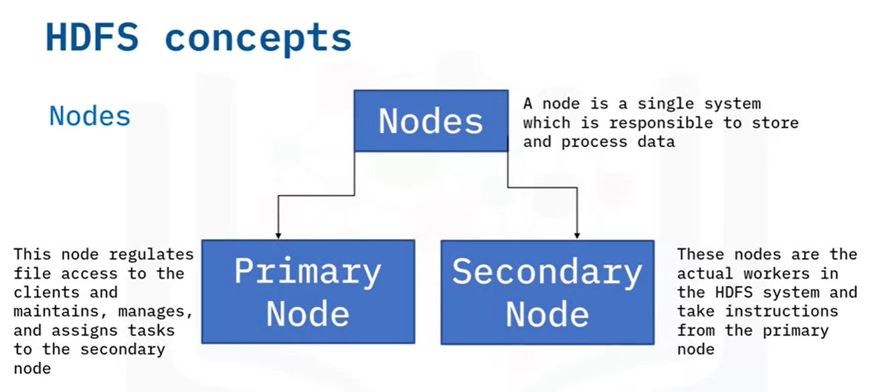

**Rack awareness**:

Nodes know where other nodes are. Replication happens on nodes not having the same rack.

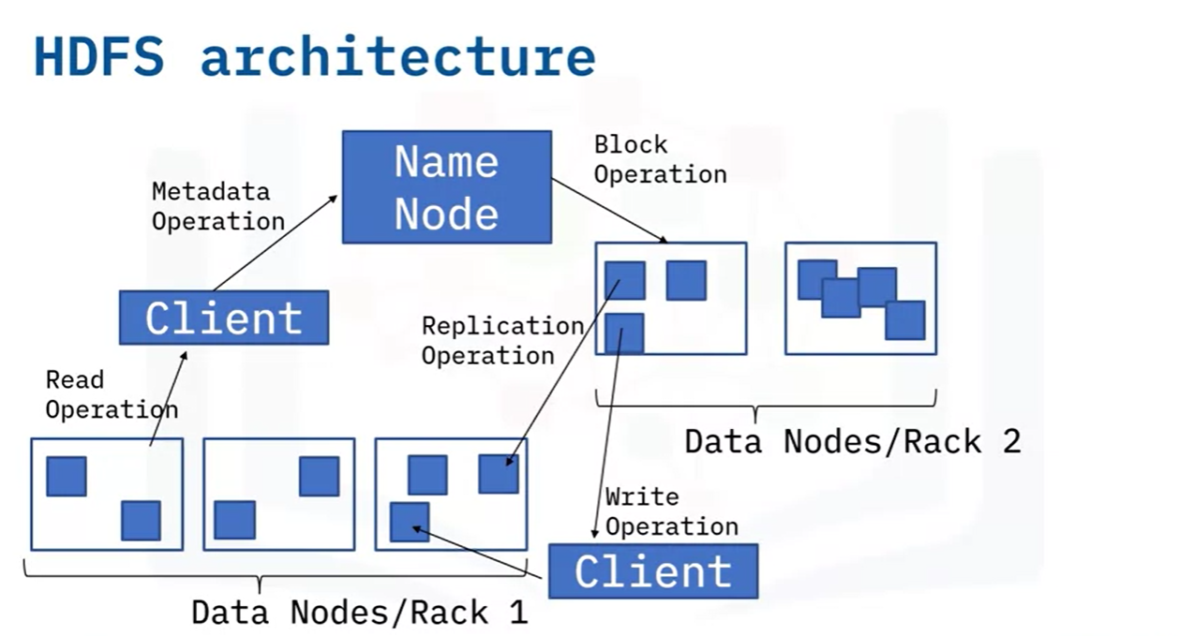

HDFS allows write once, read many operations

## Hive

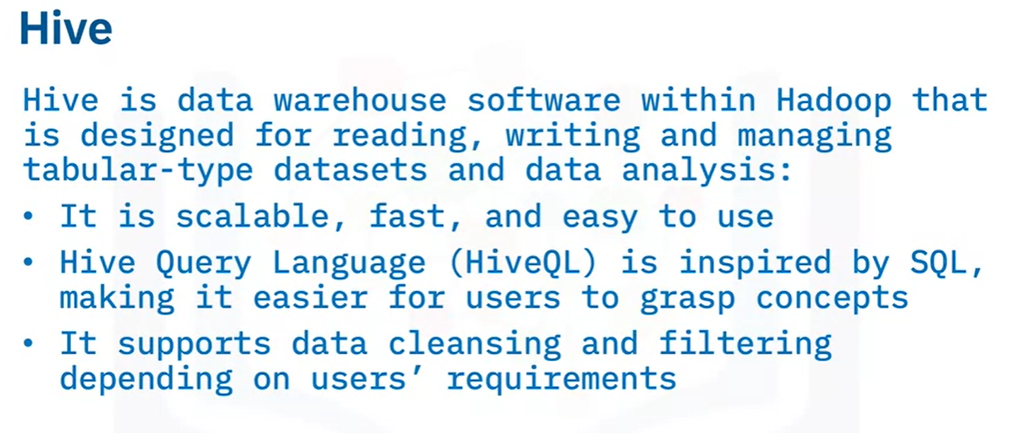

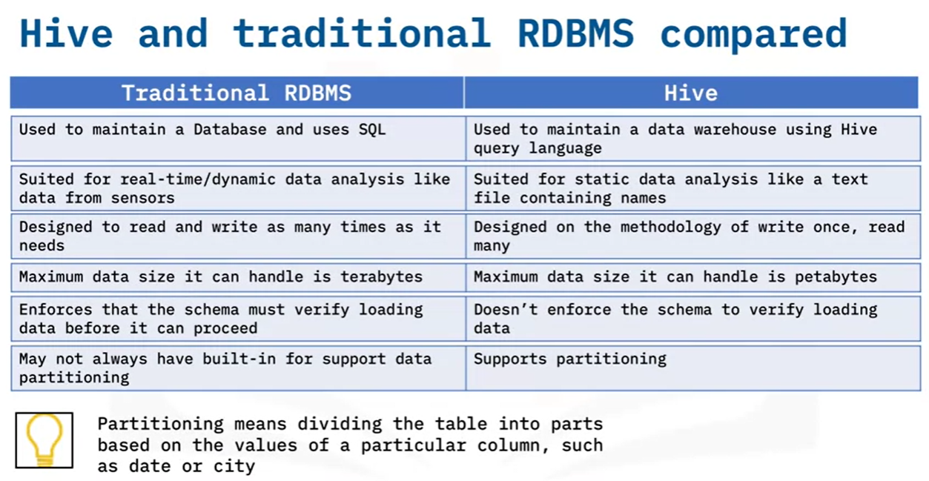

## HBASE

Columnar non-relational database. Write-heavy

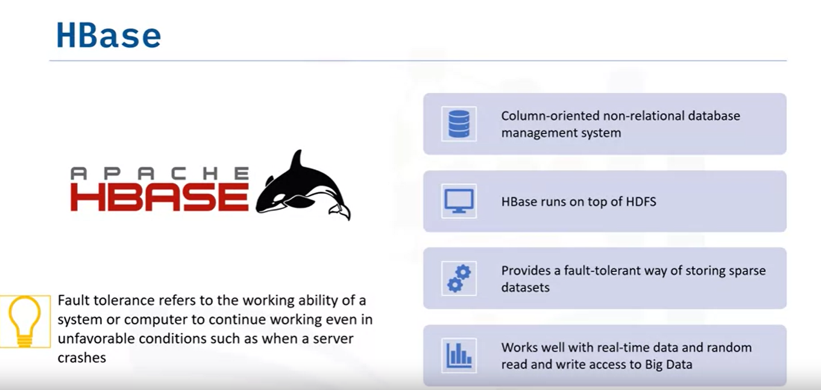

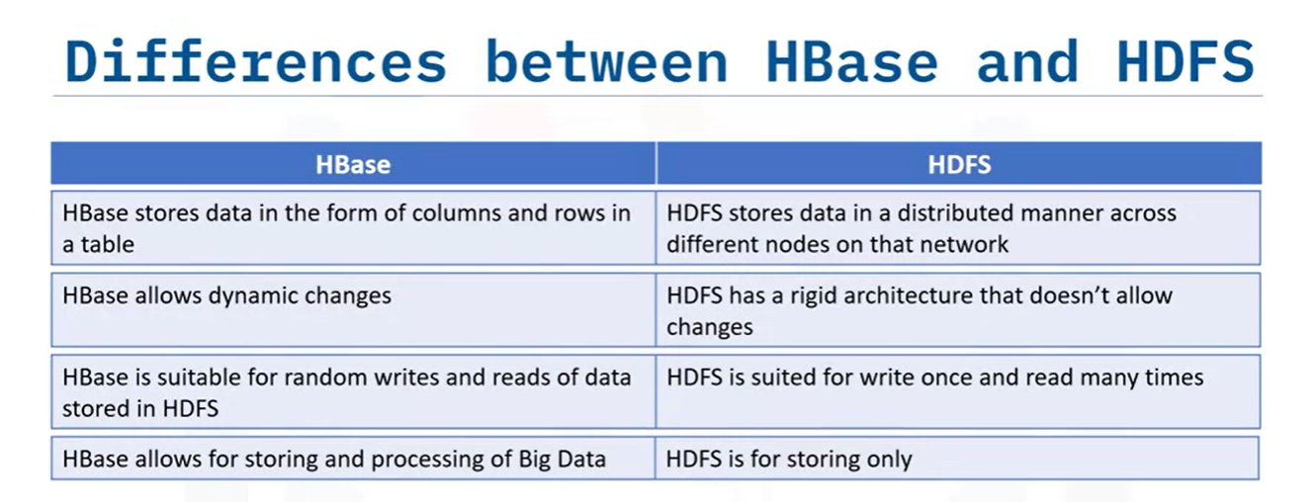

## Installation Hadoop

|  |
| --- |
| curl https://dlcdn.apache.org/hadoop/common/hadoop-3.2.3/hadoop-3.2.3.tar.gz --output hadoop-3.2.3.tar.gz  tar -xvf hadoop-3.2.3.tar.gz  cd hadoop-3.2.3  # To see usage commands  bin/hadoop |

# Apache Spark

**In-memory** framework for **distributed** data processing.

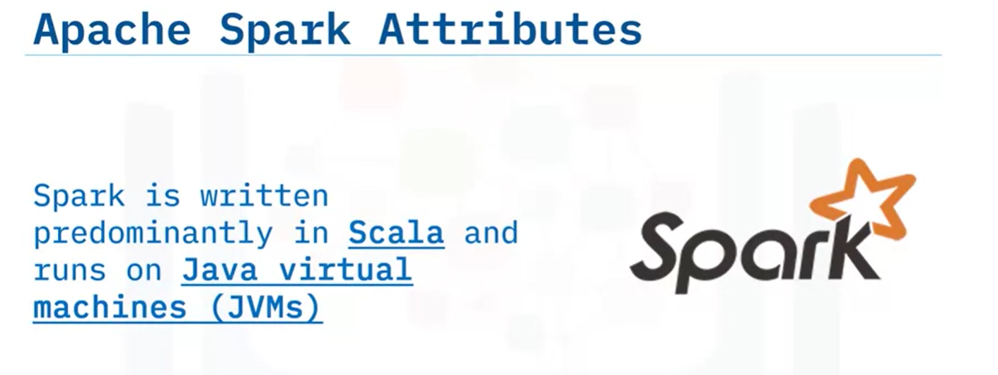

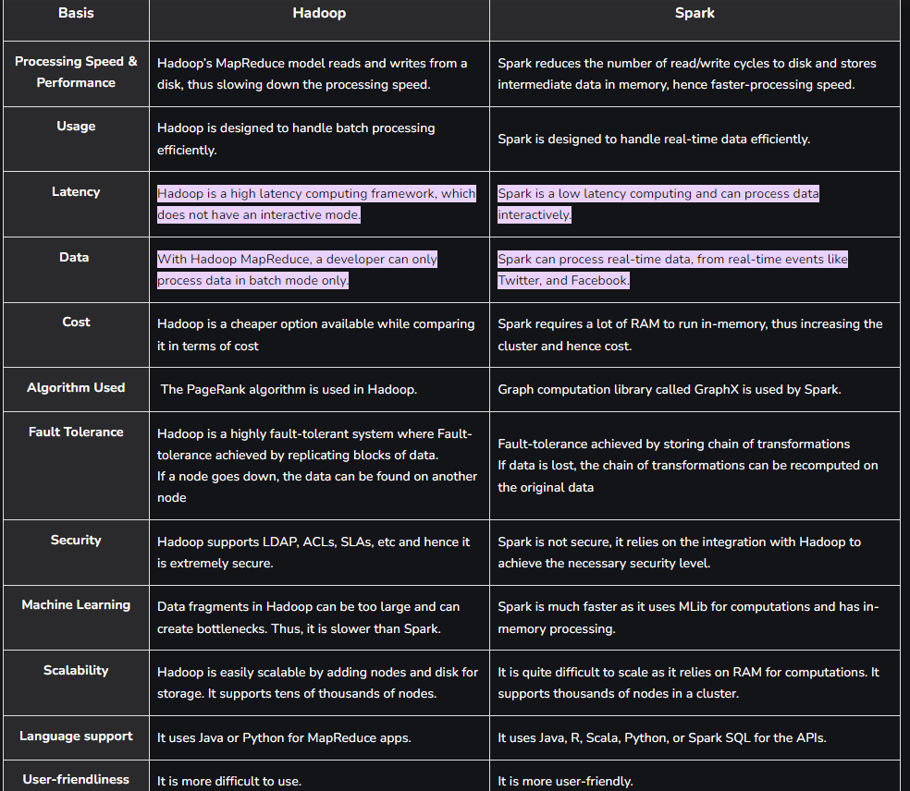

## Parallel vs Distributed Computing

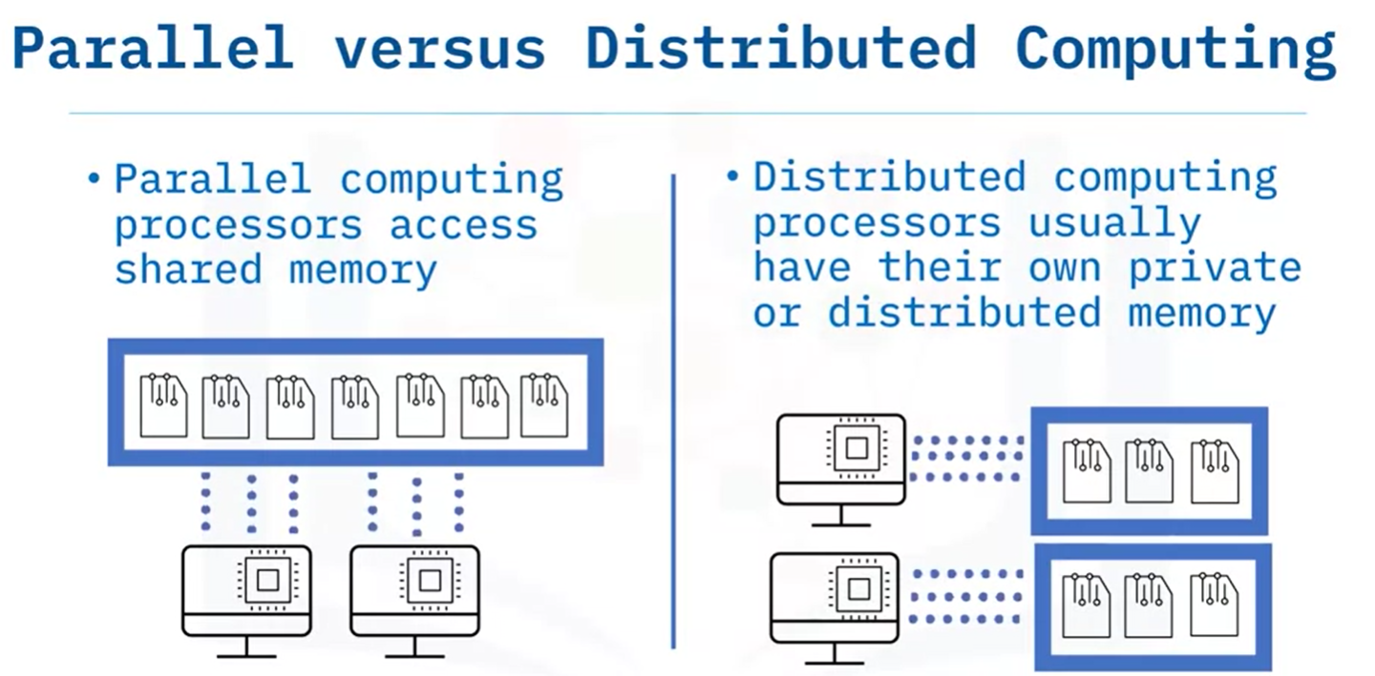

### Benefits of Distributed Computing

Scalability and modular growth. Additional machines can be added

They are fault tolerant and redundancy.

No special hardware is needed e.g. GPU

### Spark vs MapReduce

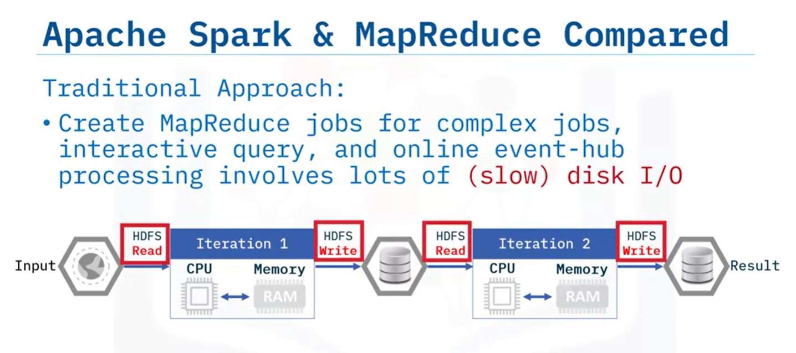

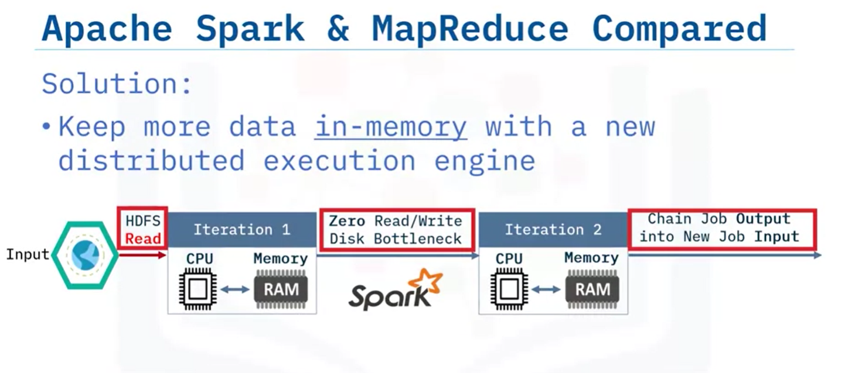

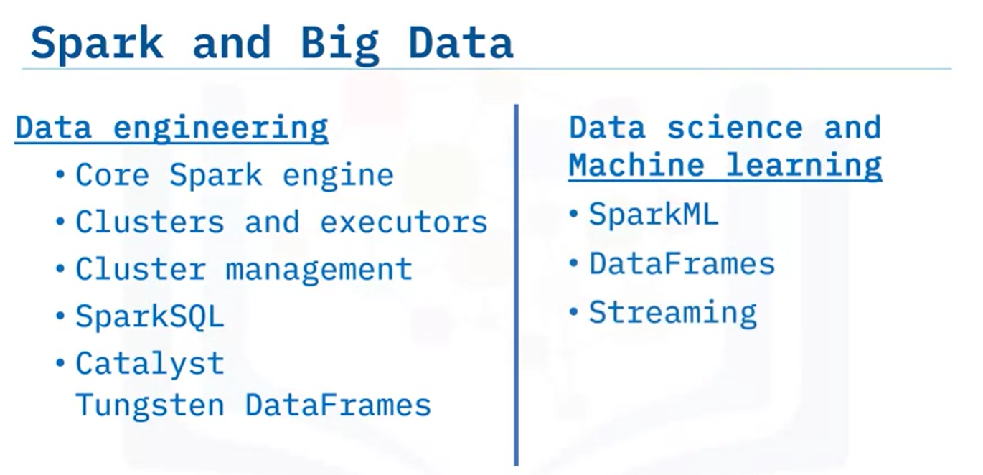

## Functional Programming

Follows mathematical function format i.e. f(x) lambda function

Scala is the most recent functional programming language. Functions can be passed as inputs or outputs.

e.g. df.apply(lambda x: x+1, axis=1)

Parallelization is feature of functional programming

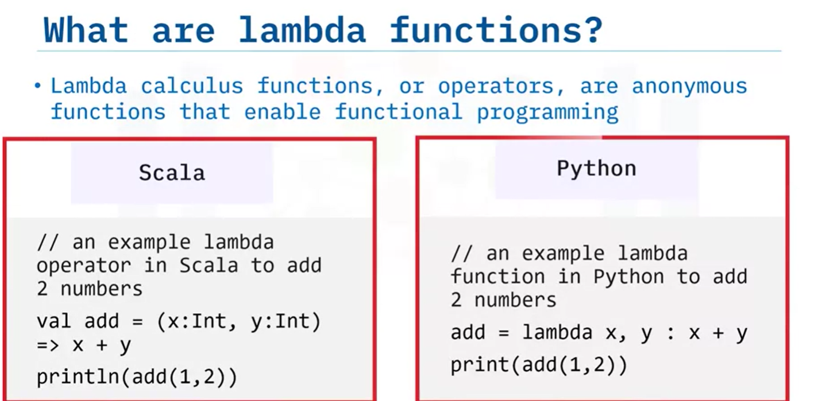

All functional spark programs are inherently parallel.

## Resilient Distributed Dataset (RDD)

Fault tolerant datasets, partitioned across nodes, can accept parallel operations

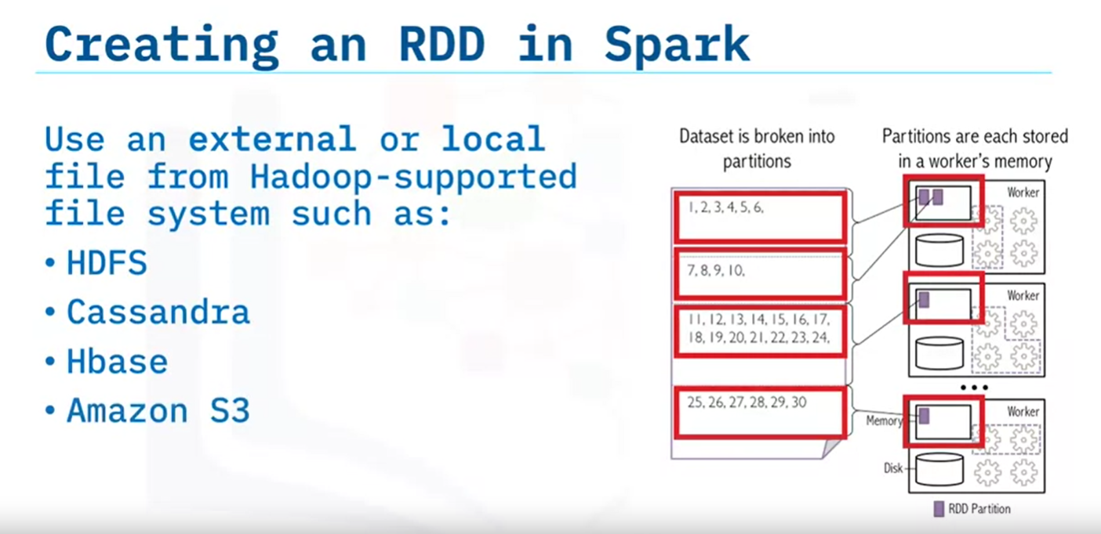

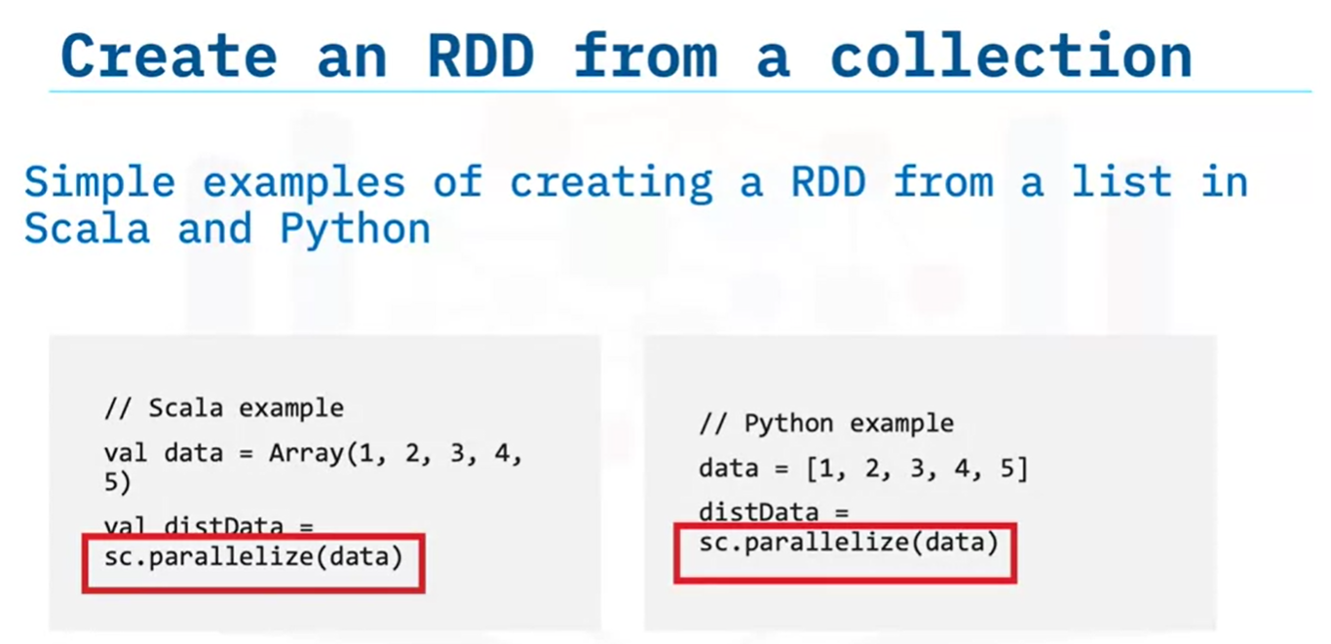

Partitions can be set using 2nd argument

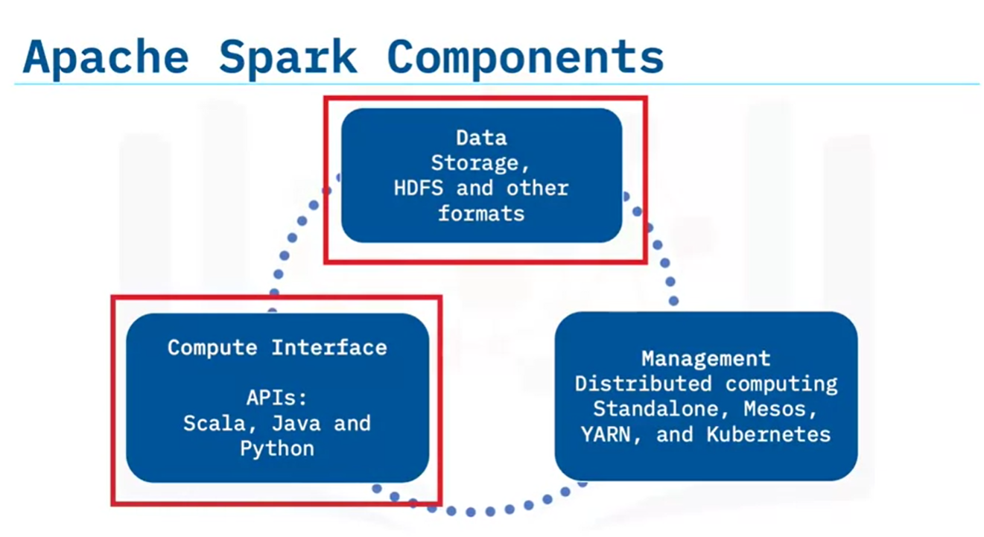

## SparkSQL

Used to query **structured** data using SQL queries.

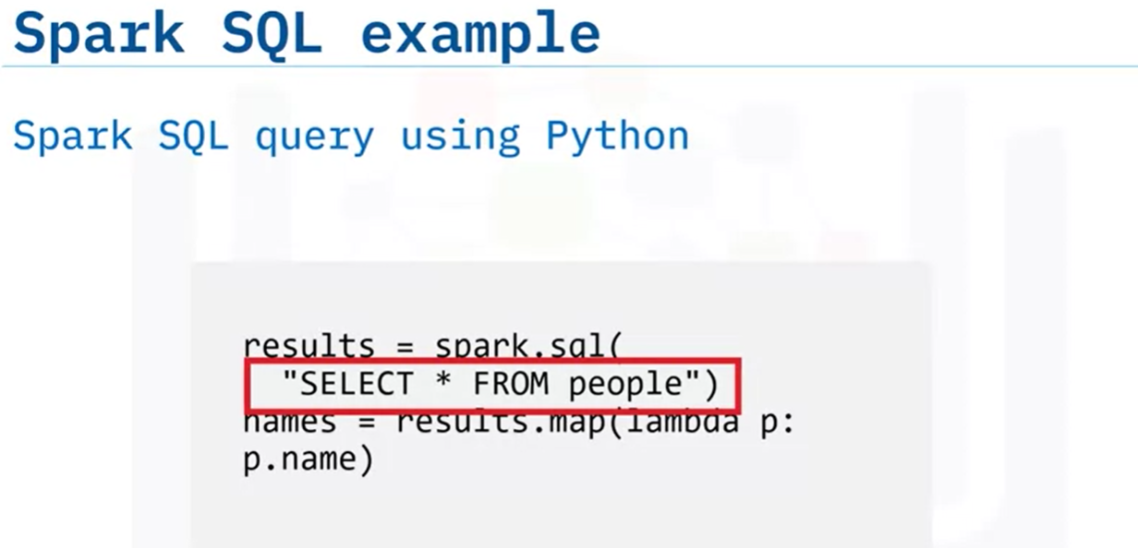

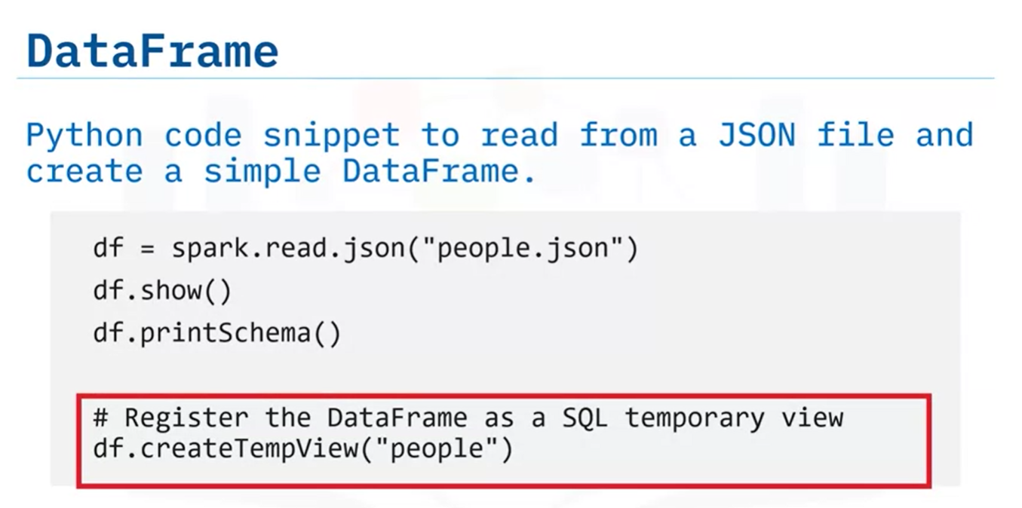

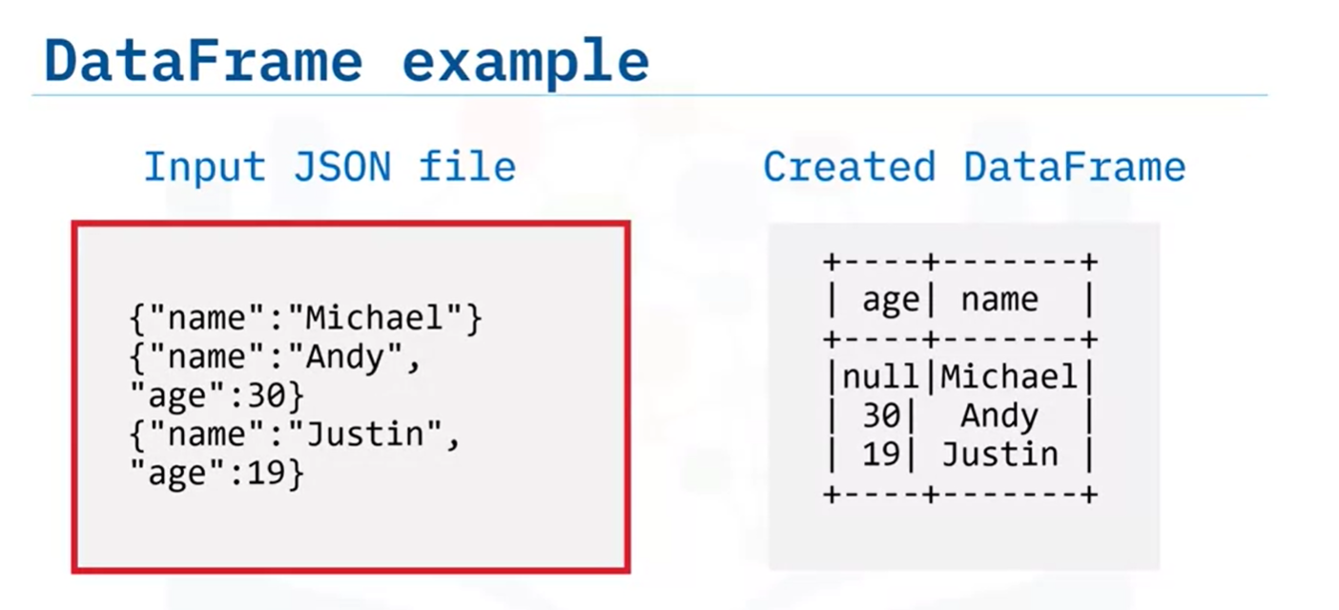

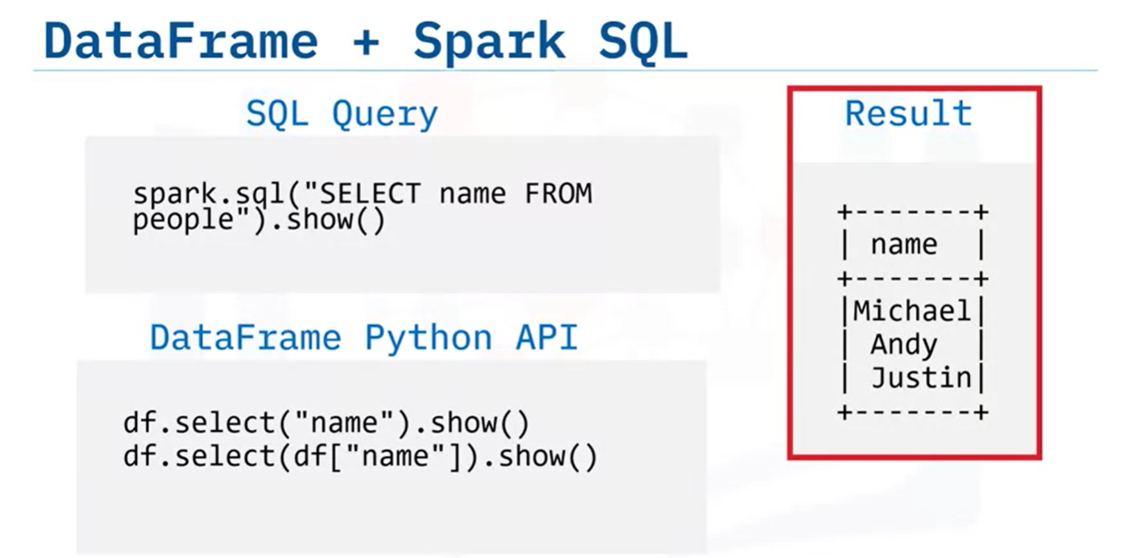

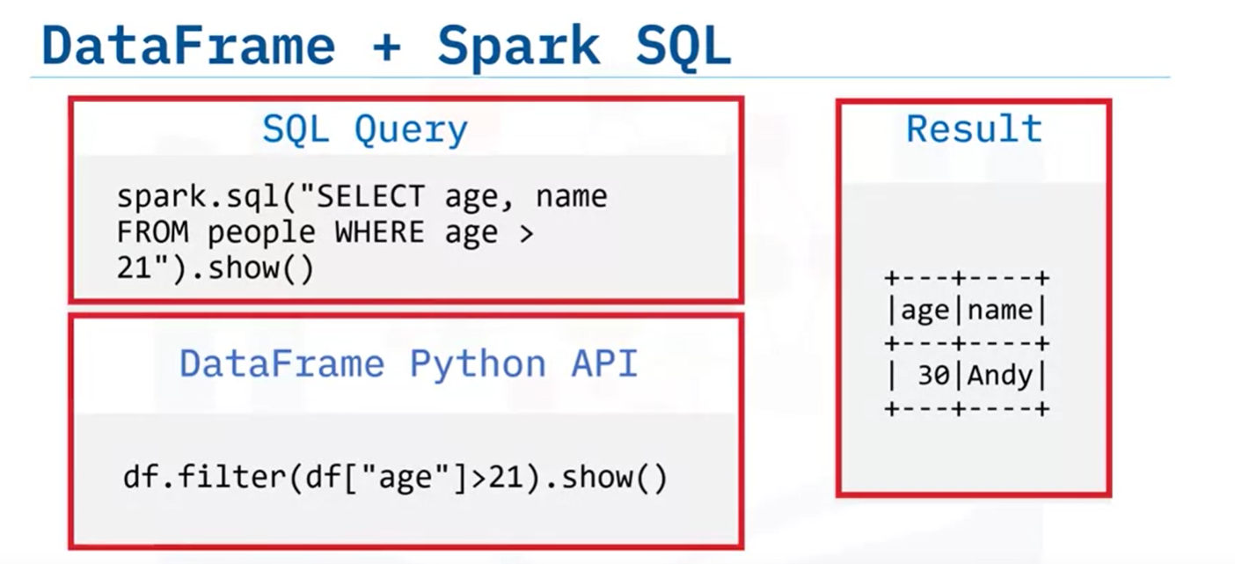

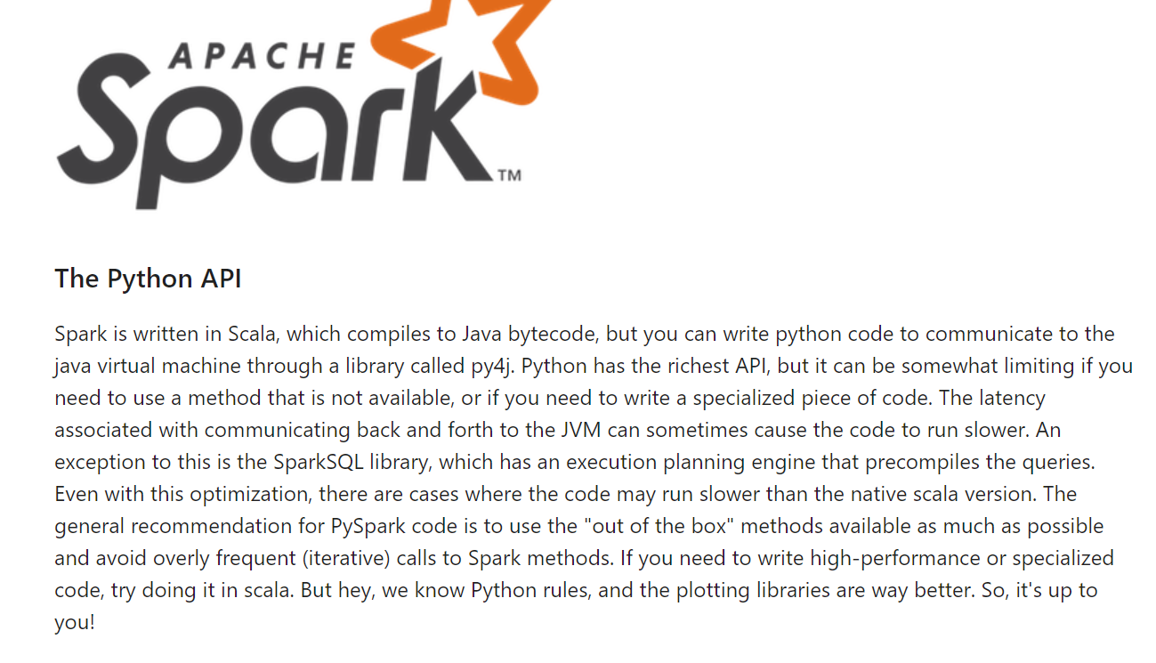

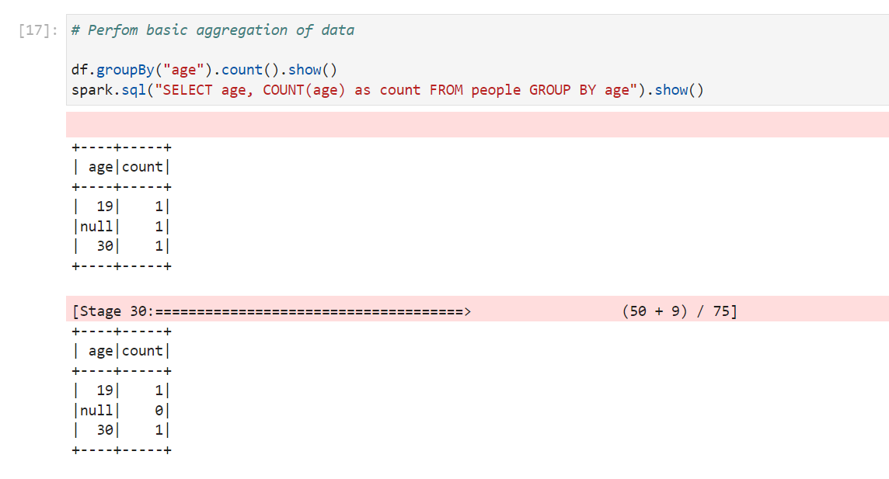

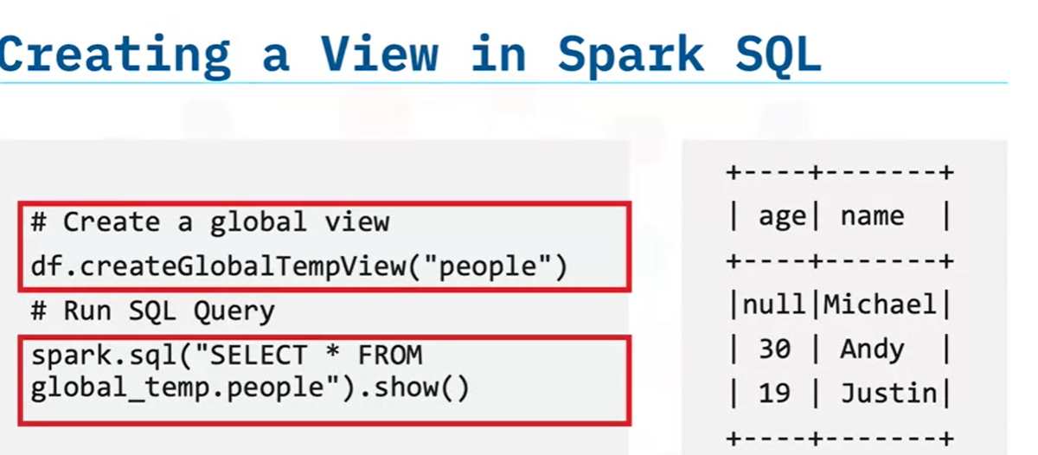

## RDD in Parallel Programming

Transformations in spark are lazy, i.e. they are not immediately calculated

To evaluate, you use an action, which returns result.

Map() # doesn’t run function

Reduce() # returns function immediately

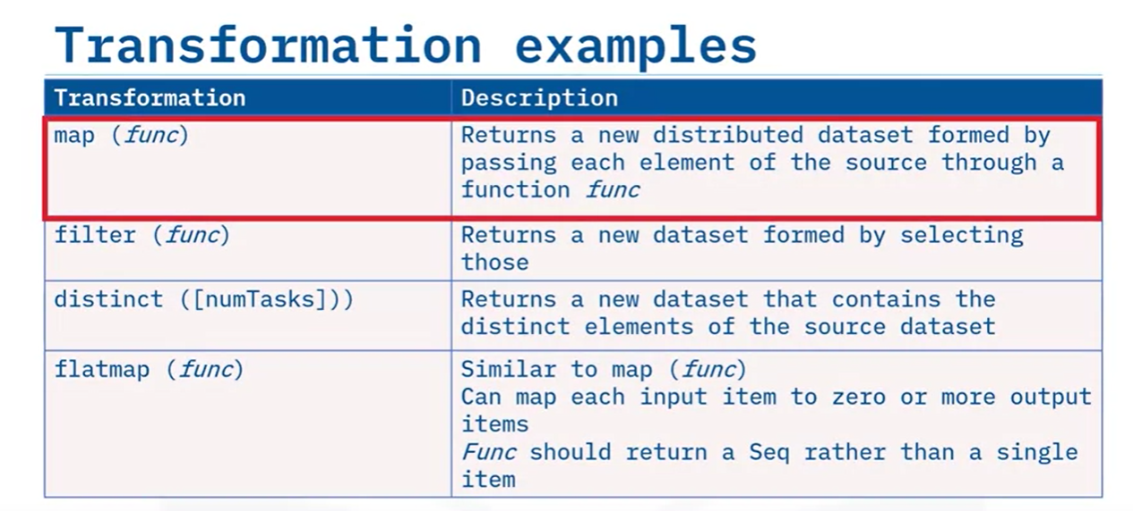

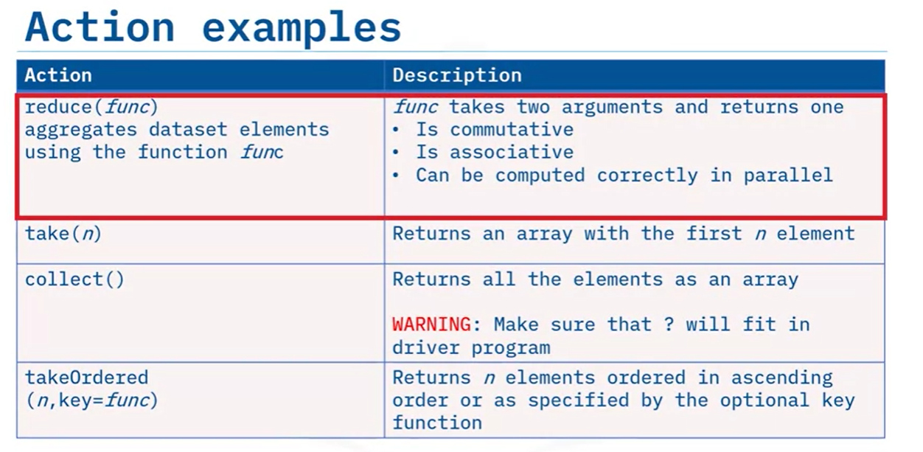

## Datasets

Strongly typed so only supported in Scala and Java. Not supported in dynamic languages like Python and R.

They have benefits of both dataframes and RDDs.

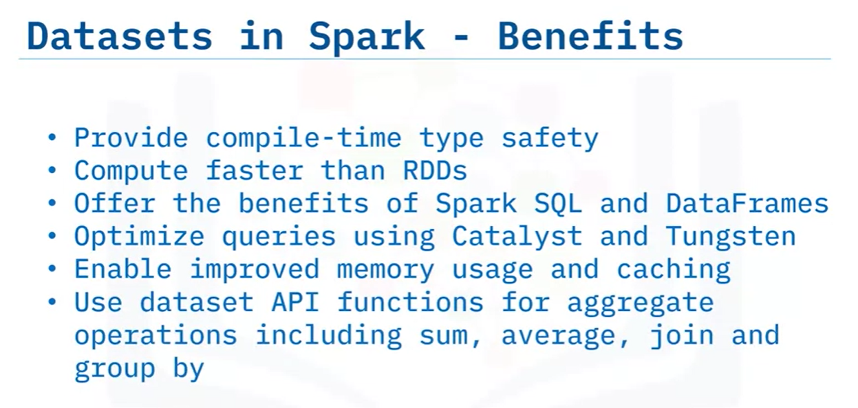

### How to create dataset (Scala)

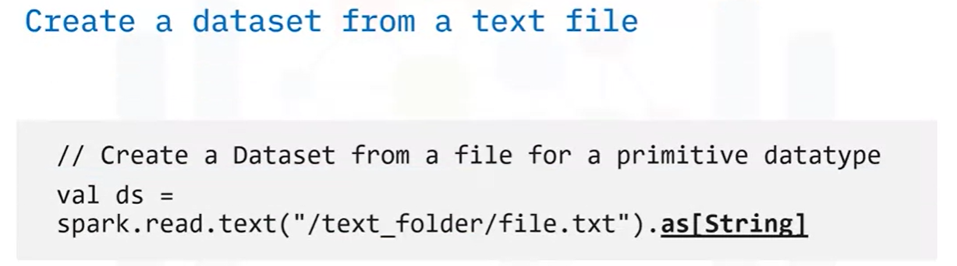

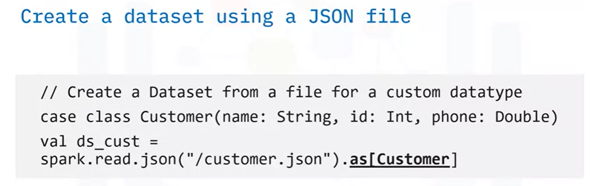

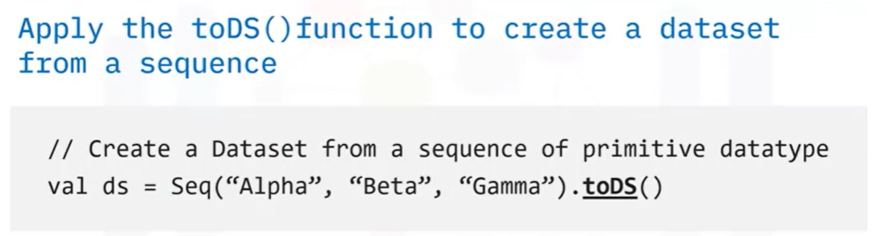

## Memory Optimization using Catalyst and Tungsten

To reduce memory usage and run time.

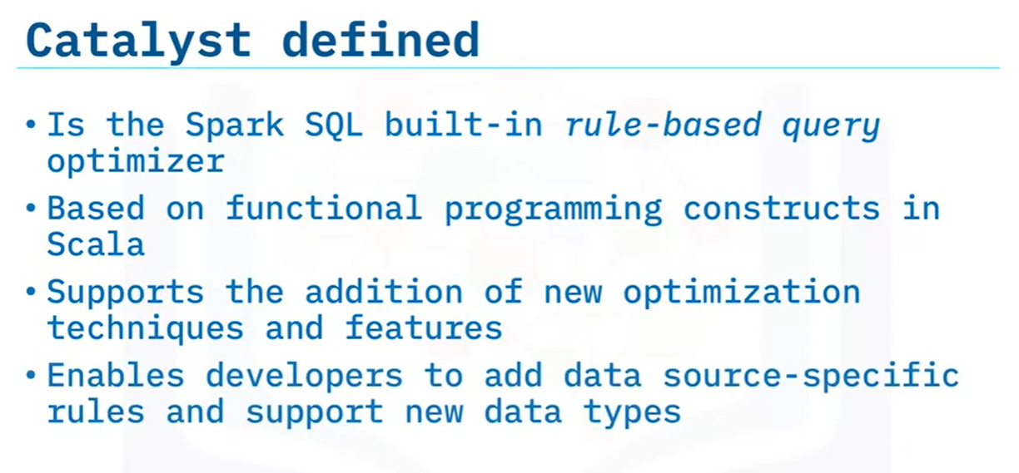

Is table indexed.

Are only required columns included in result

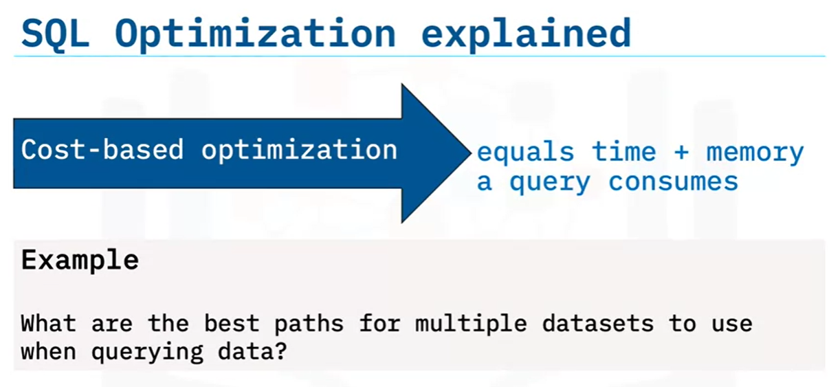

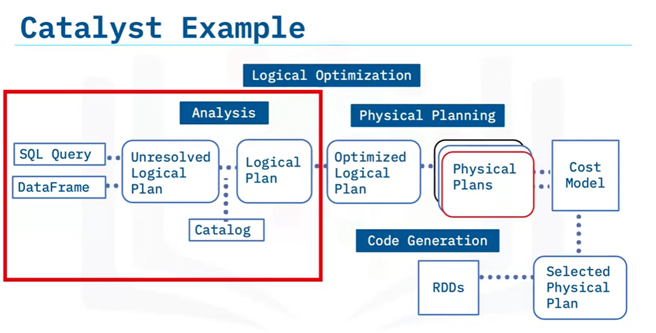

Java bytecode is generated to run on each node.

## ETL with DataFrames

|  |
| --- |
| import pandas as pd  Mtcars = pd.read_csv(‘mtcars.csv’)  Sdf = spark.createDataFrame(mtcars)  # Note datatype of each column using  Sfd.printSchema()  # To see 5 rows of mpg column  Sdf.select(‘mpg’).show()  ## Transformations  Sdf.filter(Sdf[‘mpg’]<18).show()  Sdf.groupby([‘cyl’]).agg({“wt”: “count”}) |